Homework 9

Problem 1

Using:

ϵ = 0.26 mm

The inlet pressure was calculated by Aspen to be 35.1 atm

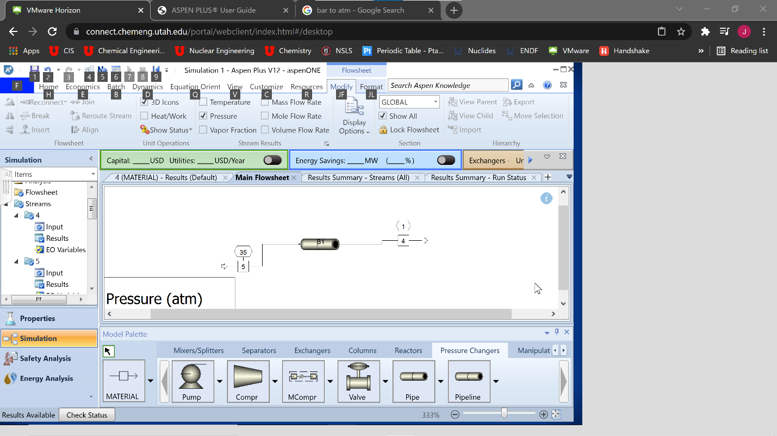

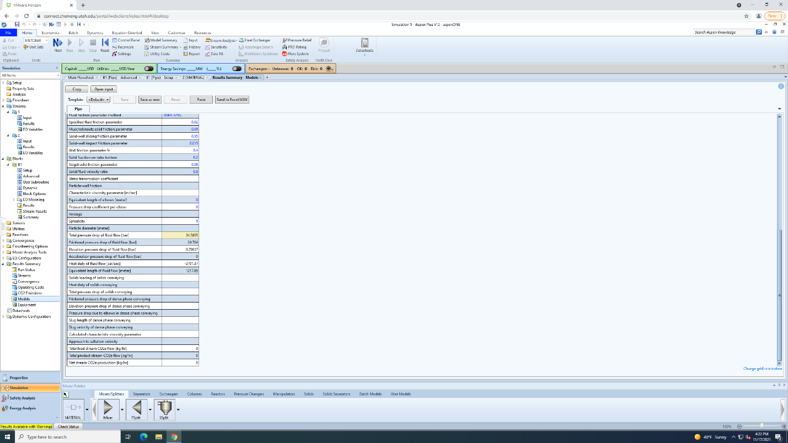

Problem 2

Hpump=450 ft

=112200 112200/550 = 204hp

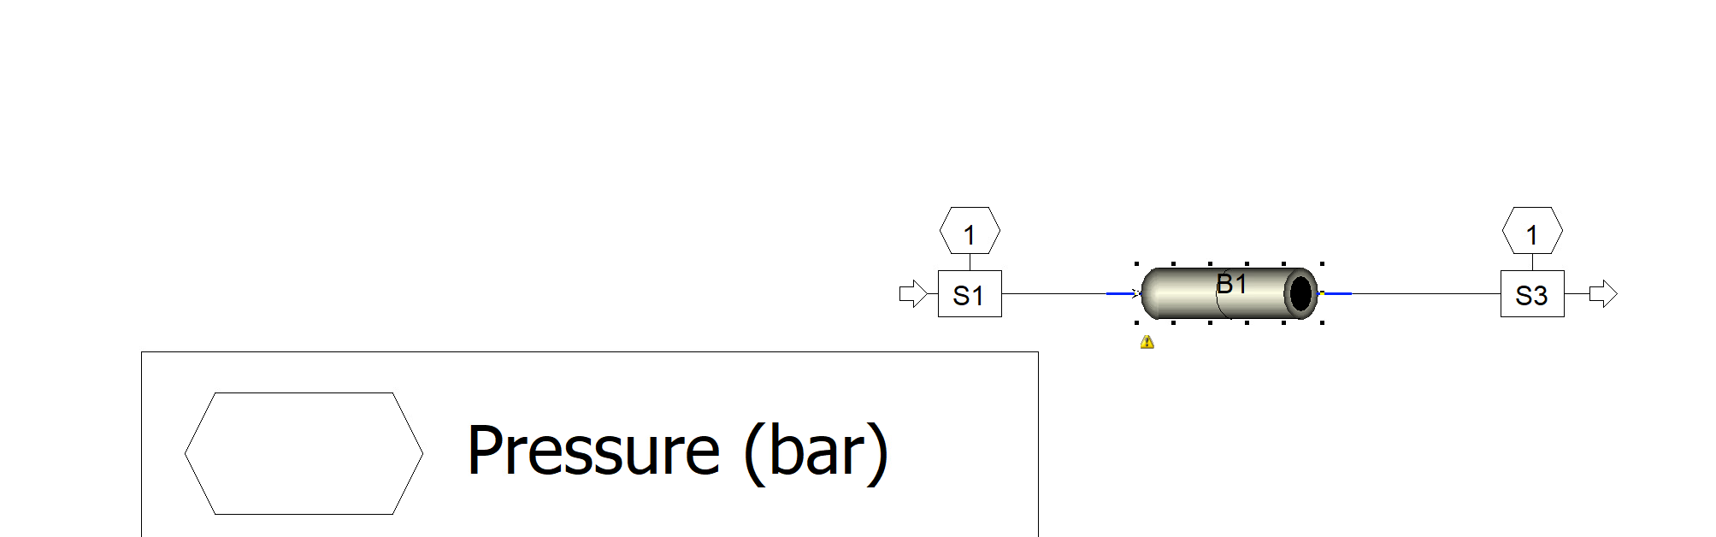

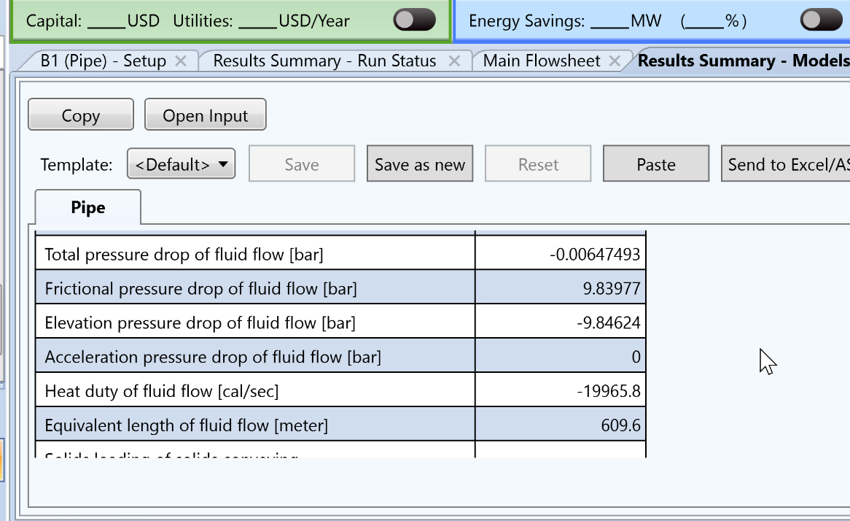

Problem 3

Using k=4.5:

Re = 12000, Flow is Turbulent

Total head drop = 36\*12 = 432 ft

